|  |  |  |  |  |
| --- | --- | --- | --- | --- |
| **WHS Procedure Title:** | |  | | |
| **WHS Procedure No.** | |  | **Authorised Date** | 03 March 2024 |
| **Review:** | Annual General Meeting Executive & Management Committee Meeting- March each year | | | |

# Purpose and Scope

This procedure outlines the requirement to establish an Emergency Management Plan for Ingleburn RSL sub Branch. This procedure applies to all Sub Branch Workers and other PCBU representatives and other persons whilst on Sub Branch sites.

# Sub Branch sites

Sub Branch Sites include:

* Main Sub Branch Office located in Club Ltd premises;
* Gardens and Park Office;
* Ingleburn RSL Sub Branch Memorial Gardens;
* Sister Helen FJC Haultain Memorial Park;
* Sub Branch Bus;
* Offsite areas e.g. Service Members/Auxiliary homes, Hospitals, Nursing homes

# Context

Ingleburn RSL Sub Branch is required, under the cl.43 WHS Regulation 2017, to be prepared for emergency situations that may arise at the workplace. Putting together an Emergency Management Plan will help ensure all stakeholders are well prepared. The following checklist on the next page must be used to review the plan annually.

# Reporting

All incident must be recorded and consulted on and recorded in sub Branch Meeting minutes. Any notifiable incidents must be reported to SafeWork NSW.

|  |
| --- |
| **Responsibilities** |
| Is there a plan on emergency response – Emergency Response Plan – sub Branch Park |
| Has the plan been approved by management – consulted on Honorary Secretary and Manager GAPs |
| Has the plan been distributed to all who need to know – posted Lunch Room & workshop |
| Who~~/which~~ ~~people~~ can declare a full evacuation:   1. Warden 1 – Manager Gardens and Park (GAPs) – Paul Gribble; 2. Warden 2 – John Hurcum - First Aider. |
| Who~~/which people~~ can declare an emergency over:   1. Warden 1 – Manager Gardens and Park (GAPs) – Paul Gribble; 2. Warden 2 – John Hurcum - First Aider. |
| Is the emergency plan for the workplace reviewed to ensure it remains effective – Reviewed Annually and after an activated response. |
| Has someone with appropriate skills been made responsible for specific actions in an emergency (e.g. appointment of an area warden)   1. Warden 1 – Manager GAPs – Paul Gribble    1. Collect Fire PPE (Safety Vest)    2. Raise Verbal Alarm – “Fire Fire Fire”    3. Check areas of fire if unable to control Evacuate Park Team    4. Task Warden 2 to Evacuate Park Team    5. Clear all GAPs sites and move to assigned Assembly point;    6. Report to NSW Fire and Rescue team on arrival. 2. Warden 2 – John Hurcum, Fire Warden and First aider    1. Collect Fire PPE and Kit (Safety Vest & First Aid Bag)    2. Gather Park Team at nearest Exit Gate and move to the Assigned Assembly Point;    3. Check Park Attendance Record and monitor any required first aid. |
| Is there someone responsible for making sure all workers and others in the workplace (e.g. contractors, customers and visitors) are accounted for in an evacuation? You may use attendance records for this purpose   1. Warden 1 – Paul Gribble (Gather sign in record) |
| Are specific procedures in place for critical functions such as power or gas isolation Warden 1 – Paul Gribble |
| **Emergency Contact Details** |
| Are emergency contact details (relevant to the types of possible risks, e.g. the Ambulance Service of NSW, Fire and Rescue NSW, the NSW Rural Fire Service, the NSW Police Force, the State Emergency Service, the NSW Volunteer Rescue Association Inc, displayed at the workplace in an easily accessible location   1. 000 |
| Are contact details updated regularly – reviewed regularly |
| Who will notify emergency service organisations:   1. Warden 1 – Manager Gardens and Park (GAPs) – Paul Gribble |
| **Work Environment** |
| Have you considered what type of emergencies might occur in your workplace when preparing the emergency plan? Consider emergencies arising from your workplace, and also from outside your workplace   1. Electricity & Power; 2. Hazardous Chemicals – fumes and fire; 3. Diseases; 4. Hazardous Manual Tasks; 5. UV Radiation; 6. Ladders; 7. Lighting; 8. Noise; 9. Plant and Equipment; 10. Bush Fire Smoke; 11. AOD; 12. Asbestos; 13. Psychosocial; 14. Remote or Isolated work; 15. Motor Vehicles; 16. Sedentary work; 17. S/T/Falls on same level; 18. Structures. |
| Have Sub Branch members, workers, neighbouring businesses (if relevant) been consulted in the development of the plan.   1. Ingleburn RSL Sub Branch Executive and Management Committee 2. Sub Branch members (monthly meeting minutes) 3. Ingleburn RSL Sub Branch Club Ltd management – Reception Desk on the day |

|  |
| --- |
| **Work Environment (continued from previous page)** |
| Is there a mechanism, such as a siren or bell alarm, for alerting staff of an emergency:   1. Warden 1 (Safety Vest) Raises Verbal Alarm – “FIRE FIRE FIRE” |
| Is there a site plan that illustrates the location of fire protection equipment, emergency exits  and assembly points (attached to this plan) | |
| If there is a site plan, is it posted in key locations throughout the workplace | |
| Are the following documents displayed in the workplace: evacuation plan, emergency contacts, first aid equipment locations | |
| Are all exits, corridors and aisle ways kept clear of obstructions and does the workplace have illuminated exit signs | |
| Are procedures in place for assisting mobility impaired people | |
| Are emergency procedures regularly tested as per requirements in the plan | |

|  |
| --- |
| **Information, training and instruction** |
| Are relevant workers informed, trained and instructed in relation to implementing the emergency procedure |

|  |
| --- |
| **Fire Protection and Fire fighting Equipment** |
| Does the workplace have fire protection and fire fighting equipment - Dry Powder |
| Is the fire protection and fire fighting equipment suitable for the types of risks at the workplace (e.g. foam or dry powder type extinguishers for fires that involve flammable liquids) |
| Is equipment regularly tested by a local fire authority or fire equipment supplier |
| Is equipment kept clear of obstructions |
| Are workers trained to use fire extinguishers where required and do they know what type of extinguisher to use for different types of fires – refresher training required |

|  |
| --- |
| **Hazardous chemicals** |
| Are current safety data sheets available for all hazardous chemicals on site |
| Are all hazardous chemicals labelled and stored in a safe manner – original containers |
| Is appropriate equipment available to initially respond to a hazardous chemical incident, such as absorbent material to contain a liquid spill – Sill Kit (Bucket of sand, SM Shovel, Broom, garbage bag, appropriate disposable coveralls |
| Is appropriate personal protective equipment (PPE) and training provided to protect workers who are called on to deal with a hazardous chemical release |
| ***Note:*** *If you own a small business that stores a large amount of hazardous chemicals, visit the SafeWork NSW website at* [*workcover.nsw.gov.au*](http://www.workcover.nsw.gov.au/) *or call 13 10 50 to find out more about any additional requirements you may have.* |

|  |
| --- |
| **Bushfire Danger Ratings** |
| If your business is located in a bushfire danger area, have you reviewed your existing fire risk controls to ensure they will be effective in bushfire danger conditions – monitor Bushfire Smoke when required |
|  ~~Have you reviewed your workplace emergency evacuation procedures for days of declared fire ratings (e.g. code red catastrophic, extreme etc) to include matters such as:~~  ~~- safe exit routes (i.e. which roads are open and closed)~~  ~~- the closest designated ‘safe place’~~  ~~- consistency with the evacuation procedures of the relevant local authorities  (e.g. Rural Fire Service and police)~~  ~~- employee access to reliable communication equipment~~ |
|  ~~Have your workers been trained in the bushfire emergency evacuation procedures~~ |
|  ~~If your workers are required to travel into areas where fire ratings such as code red or extreme may be declared, have you developed appropriate policies and procedures for when such declarations are made~~ |

|  |  |  |
| --- | --- | --- |
| **First Aid** | | |
| Has first aid equipment been provided for the workplace | | |
| Does each worker at the workplace have access to the equipment, and access to facilities for the administration of first aid | | |
| Have an adequate number of workers been trained to administer first aid at the workplace, or do workers have access to an adequate number of other persons who have been trained to administer first aid | |
| Have you conducted a first aid assessment |

|  |
| --- |
| **Neighbouring Businesses** |
| Have you considered neighbouring businesses and how you will let them know about an emergency situation should one arise – verbally advised Duty Manager, follow by Hon/. Secretary to Club CEO |
| Have you considered the risks from neighbouring businesses (eg fire from restaurant / takeaway food outlets; Q fever from cattle yards; truck accidents on major roads etc) |

|  |
| --- |
| **Post Incident Follow-Up** |
| Are there procedures to notify SafeWork NSW about an incident where necessary (go to workcover.nsw.gov.au to see if incident is notifiable) |
| Are there procedures to ensure the cause of the emergency is determined and action is taken to prevent a similar incident occurring again |
| Are there procedures to ensure the welfare of workers after an emergency or an incident, such as medical treatment or trauma counselling – First Aider/Local GP/RSL LifeCare |

|  |
| --- |
| **Testing and Review** |
| Are emergency practice runs (eg evacuation drills) undertaken to assess the effectiveness of the EMP – Planned to practice 1 Evacuation drill every 6 months on Tuesday March / October |
| Is someone responsible for documenting and retaining results of EMP practice runs - SAO |
| Is someone responsible for reviewing the EMP and informing staff of any revisions - SAO |

Be sure to customize this list with items specific to your business needs.

**Further Information**

For further information visit SafeWork NSW

*This information sheet has been prepared using the best information available to WorkCover NSW. WorkCover NSW extends no warranties to the suitability of the information for your specific circumstances and disclaims all responsibility and liability for all expenses, losses, damages and costs you might incur as a result of the information being inaccurate or incomplete.*

**Emergency Procedure (**MUST BE POSTED IN LUNCH ROOM, WORKSHOP, OFFICE & TOILETS)

***When Fire / explosion Reported***

|  |  |  |
| --- | --- | --- |
| ***Workers*** | ***Chief Warden (White Helmet)*** | ***Warden/First Aider*** |
| *On arrival to work area ensure you have signed the Attendance Record;*  *Be prepared to evacuate when instructed;*  *Follow instructions of Warden/first Aider;*  *When at assigned Assembly point remain there until advised you can leave.* | *Check fire area if fire can not be extinguisher by 1 extinguisher raise verbal Alarm “Fire Fire Fire”;*  *Task Warden/First Aider to evacuate all attendees to assigned Assembly Point;*  *Clear all sites – Lunch room, store, container, toilets, shed, work shop, office and outside area of any attendees who have not evacuated;*  *Retrieve Attendance Record;*  *Move to Assigned Assembly Point;*  *Call the roll to confirm all attendees present;*  *Report to Fire and Rescue on arrival.* | *Organise the evacuation of attendees to the Assigned Assembly Point in an orderly fashion;*  *Provide any first aid.* |

***Fire Wardens (Instruction provided on duties Identified by Safety Vests)***

|  |  |
| --- | --- |
| ***Chief Warden***(White Helmet) – Paul Gribble | ***Warden/First Aider*** (Green Helmet) – John Hurcum |
| ***Paul Gribble*** | *John Hurcum* |

***Fire Equipment on site****:*

|  |  |
| --- | --- |
| *2 - Warden Safety Helmets (White, Green)* | *2 - Assembly Point Signage* |
| *3 – Fire Extinguishers* | *1 – Exit signage* |
| *1 – Portable First Aid Kit* |  |

*Blank page*

***Assembly Points* (**MUST BE POSTED IN LUNCH ROOM, WORKSHOP, OFFICE & TOILETS)

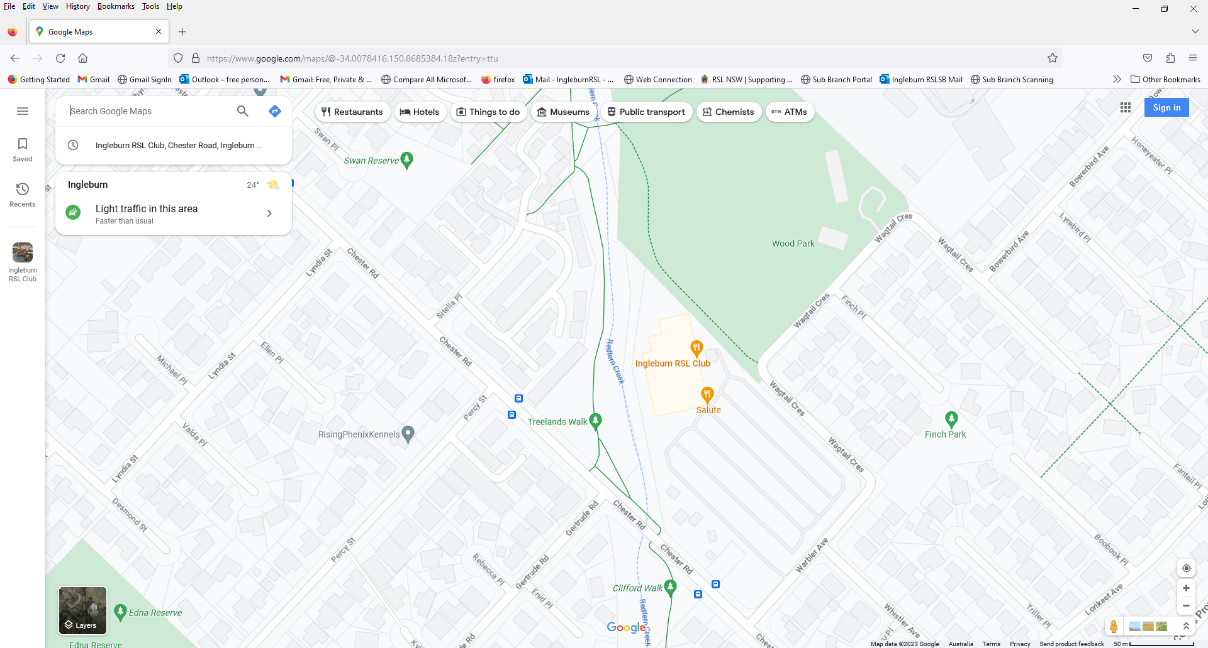

**111 Assembly Point 1** – Ingleburn RSL **Assembly Point 2** – Club Ltd Car park sign posted **Emergency Exit** via Sub Branch Memorial Garden Memorial Garden’s Top Gate

Ee EXITS

***Fire Extinguish 7 First Aid Cabinets/AED Locations* (**MUST BE POSTED IN LUNCH ROOM, WORKSHOP, OFFICE & TOILETS)

*Fire Extinguisher First Aid Cabinet*

*Workshop and Welfare and Pension Office & Pavilion Work Shop & Pavilion First Aid Cabinet*

*A:B(E)Powder AED*



Wo Workshop

WeWelfare & Pension Office

Roller

Rol Roller Doors

Sto Store

Lun Lunch Room

Toil Toilets

Rol Roller Doors